---

# 🎁 CoffeeShopSystem

## 📋 Overview

Welcome to the ** CoffeeShopSystem **!

Built with 💻 **Angular**, ☕ **Spring Boot**, and 🛢️ **Postgres**, this project helps manage donors with a modern and dynamic UI.

---

## 🚀 Features

• ➕ Add new coffee items

• 📝 Edit existing coffee item details

• 👀 View detailed coffee item info

• ❌ Delete coffee items with confirmation

• ⚡ Instant updates without reloading the page

• 🎨 Clean and simple Bootstrap design

---

## 🛠️ Technologies Used

| Frontend | Backend | Database | Styling |

|:--------:|:-------:|:--------:|:-------:|

| Angular 16 | Spring Boot | Postgres | Bootstrap 5 |

---

## 🧰 Prerequisites

Before you start, make sure you have:

- 🟢 Node.js (v14 or above)

- 🅰️ Angular CLI (v12 or above)

- ☕ Java JDK (v11 or above)

- 🌱 Spring Boot (v2.7 or above)

- 🛢️ PostgresSql

---

## 🏗️ Setup Instructions

### 📦 Backend (Spring Boot)

1. Clone the repository:

```bash

git clone https://github.com/pratikshabadhe1822/CoffeeSystem_SpringBoot_Angular.git

```

2. Navigate to the backend project folder:

```bash

cd [CoffeeSystem_SpringBoot_Angular](https://github.com/pratikshabadhe1822/CoffeeSystem_SpringBoot_Angular/blob/main/CoffeeSystem_SpringBoot_Angular) /backend

```

3. Update your MySQL database settings in `application.properties`.

4. Run the Spring Boot application:

```bash

mvn spring-boot:run

```

✅ Backend runs at: `http://localhost:8090`

---

### 🎯 Frontend (Angular)

1. Navigate to the frontend folder:

```bash

cd [CoffeeSystem_SpringBoot_Angular](https://github.com/pratikshabadhe1822/CoffeeSystem_SpringBoot_Angular/blob/main/CoffeeSystem_SpringBoot_Angular) /frontend

```

2. Install dependencies:

```bash

npm install

```

3. Run the Angular dev server:

```bash

ng serve

```

✅ Frontend runs at: `http://localhost:4200`

---

## ✨ Outputs

### 🏡 Home Page

*Displays a list of all coffee items with options to view, edit, or delete.*

*(Example Screenshot Here if you want)*

---

**➕ Add Coffee Item**

*Add a new coffee item with name and price.*

*(Example Screenshot Here if you want)*

**✏️ Edit Coffee Item**

*Modify existing coffee item details.*

*(Example Screenshot Here if you want)*

**🗑️ Delete Coffee Item**

*Confirm before deleting a coffee item.*

*(Example Screenshot Here if you want)*

**🔗 API Endpoints**

| **Method** | **Endpoint** | **Description** |
| --- | --- | --- |
| GET | /coffeeitems/all | Fetch all coffee items |
| GET | /coffeeitems/{id} | Fetch coffee item by ID |
| POST | /coffeeitems/register | Add a new coffee item |
| PUT | /coffeeitems/update/{id} | Update coffee item |
| DELETE | /coffeeitems/delete/{id} | Delete coffee item |

**📜 License**

This project is licensed under the MIT License.

# ✨ Thank you for visiting! ✨

**👤 Author**

**Your Name**  
🔗 <https://github.com/pratikshabadhe1822/CoffeeSystem_SpringBoot_Angular.git>

ScreenShots

1. AddCoffeeItem

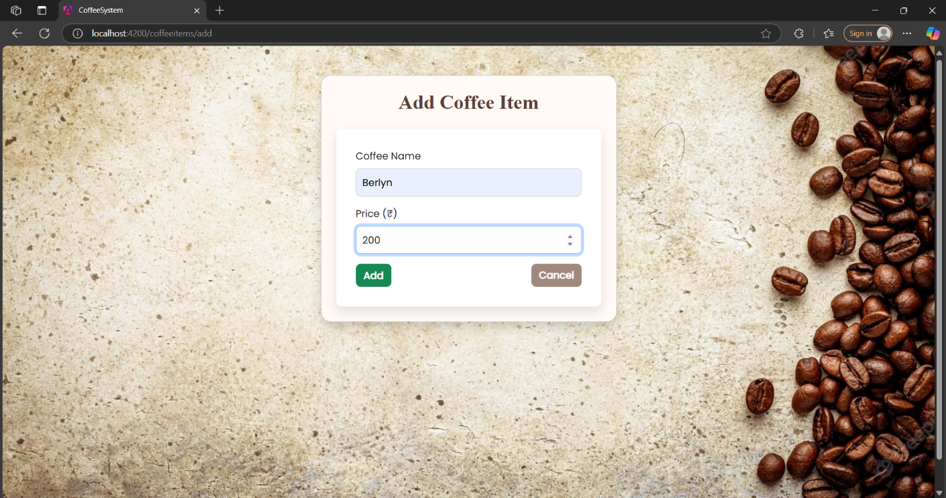

2.Display CoffeeItem

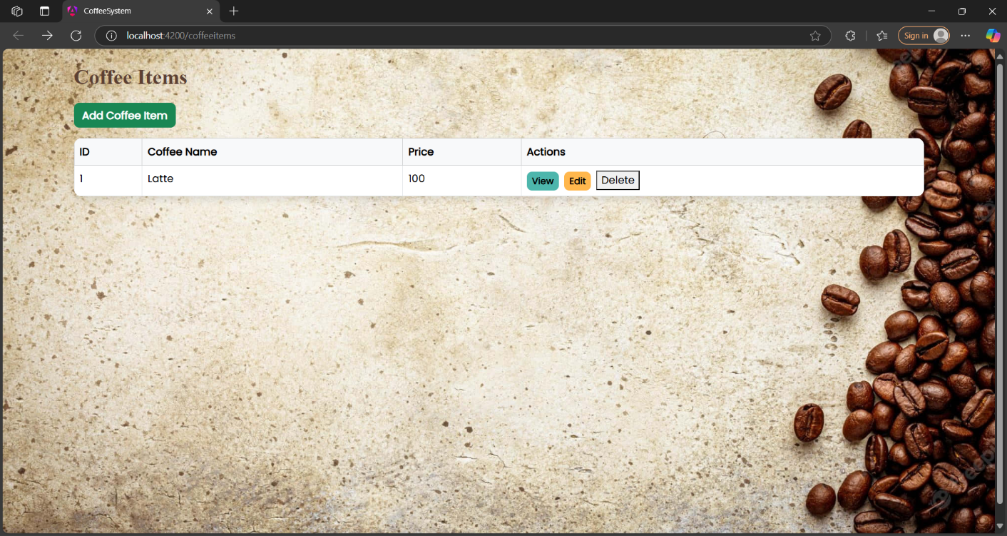

3.View CoffeeItem

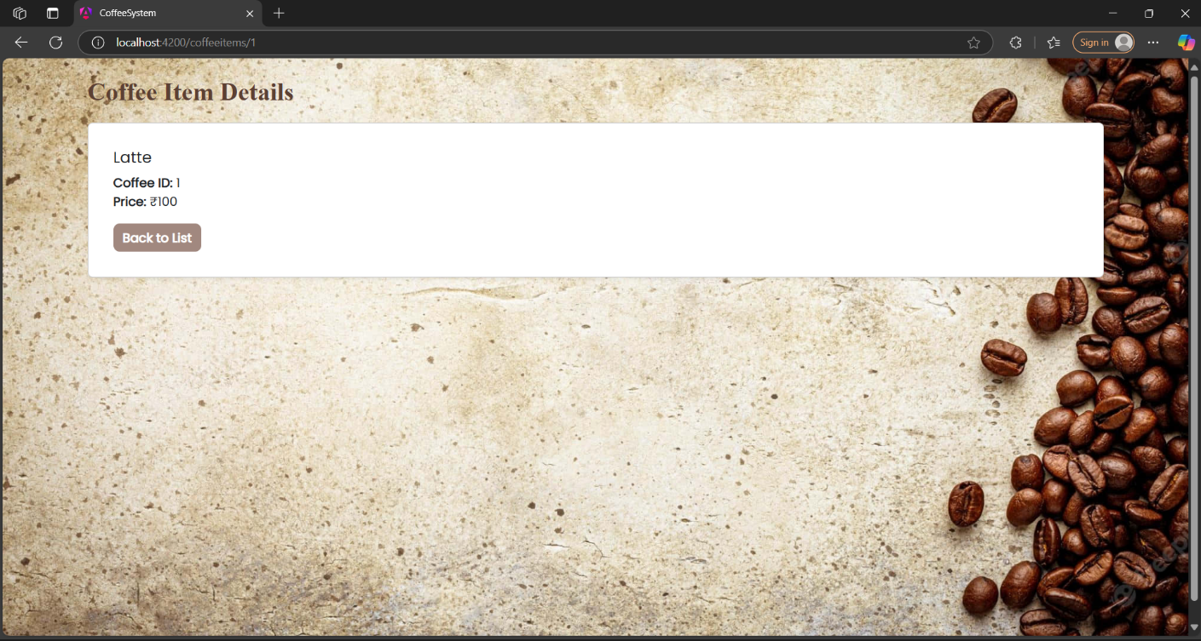

4.Edit CoffeeItem

